



High Level Architecture
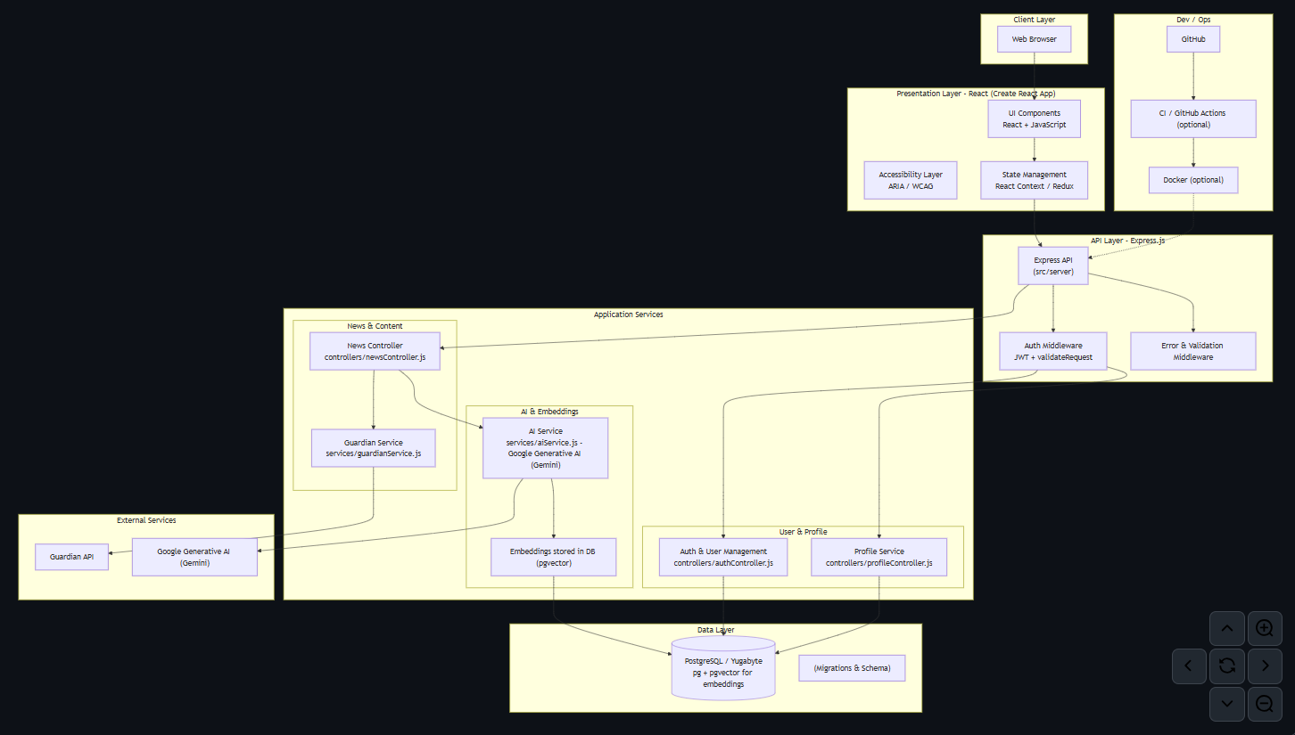
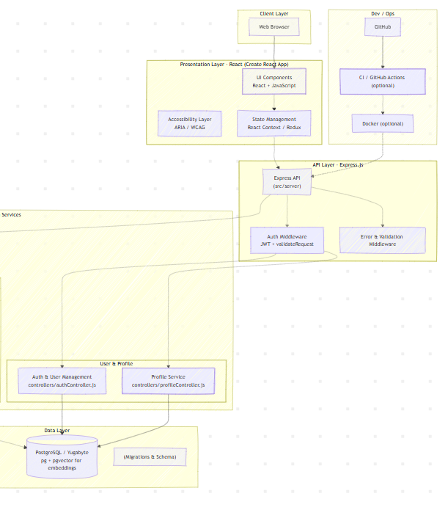
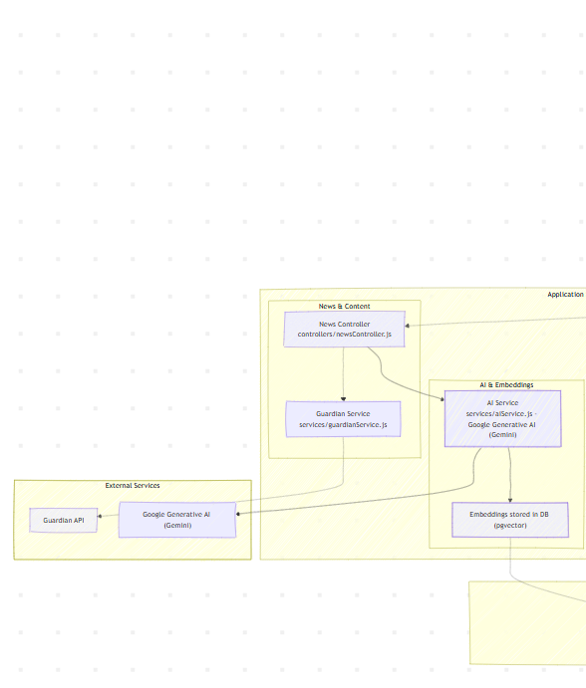

High Level Object Design
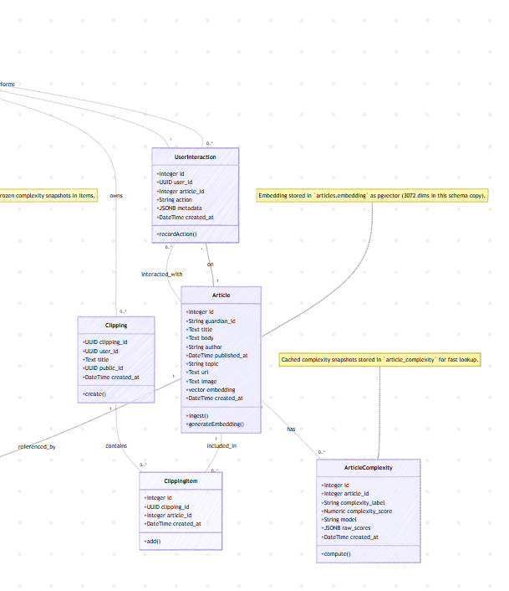
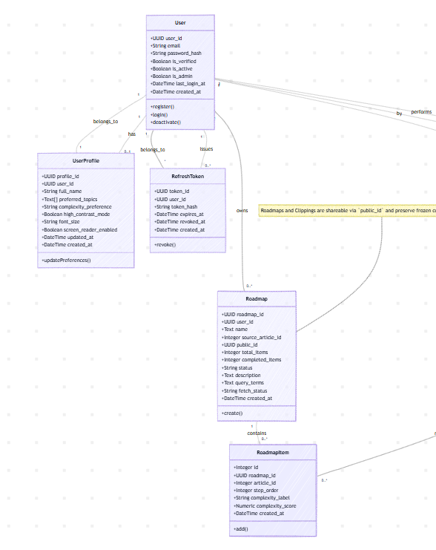

introduction
- Problem statement and project motivation
- Target users and stakeholders
- Project objectives and success criteria

requirements and design
- Key functional and non-functional requirements
- System architecture overview
- Technology stack and design decisions
- Development methodology and tools

system demo
- Key user scenarios and workflows
- Innovative features and capabilities
- System performance and integration points (APIs, databases, external services)
- User interface and user experience highlights

testing & validation
- Testing strategies employed (system test planning)
- Test cases and results
- Performance benchmarks or usability findings

reflection and future work
- Challenges overcome and lessons learned
- Current limitations and known issues
- Potential enhancements and next steps

user journeys
- User registers or logs in (email verified).
- User sets preferences (topics, reading level).
- Home displays a preference-aware carousel of headlines.
- User opens an article, reads content, and can generate a learning roadmap.
- User saves articles into clippings and can share clippings via public links.
- User views clipping recommendations and adds suggested articles to their clipping.
- (Optional, Admin) Admin manages users (promote to admin, deactivate/delete) via the admin interface.

